21.05.2018

PATENT ANALYSIS

Technology Management

Project Homework

**Contents**

*Introduction……………………………………………………………………………………………………………………1*

*Problem Definition………………………………………………………………………………………………………….1*

*Project Goals………………………………………………………………………………………………………………….2*

*Solution Approach………………………………………………………………………………………………………….2*

*Case Study…………………………………………………………………………………………………………………….3*

*Patent Analysis……………………………………………………………………………………………………………4-5-6*

*Patent Numbers Information………………………………………………………………………………………..7*

*IPC Numbers ……………………..………………………………………………………………………………………..8*

*Key Words……………………………………………………………………………………………………………………8*

*Conclusion……………………………………………………………………………………………………………………9*

*Preparet by………………………………………………………………………………………………………………….10*

**Patent Analysis of Phone Camera**

**Introduction**

*The most important factor that ensures the positive result of an investment today is that the*

*investment sector is exposed to a lot of interest and relevance by people. The resultsobtained*

*from the patent analysis give us information on how the selected industry is covered by*

*people. In this project, we will do a patent analysis of the phone cameras and we will*

*interpret the investment situation of this topic according to data which are achieved by us.*



**Problem Definition**

To determine whether people are interested in the topic which is selected by us and

whether this topic is a investment eligible sector.



**1**

**Project Goals**

*The purpose of this project is to decide whether the Phone Camera Sector can be invested or*

*not in the light of the data obtained using the website of WIPO.*

**Solution Approach**

*To determine the interest in the Phone Camera Sector with a patent analysis for a time*

*interval that we have chosen. The internet site of www.wipo.int help us for this goal.*



**2**

**Case Study:**

*🡪 Patent analysis and benchmarks make it easy to look ahead.*

*🡪 We see patent analysis as a must for a healthy arsenal*

*🡪 You can think of "PATENT ANALYSIS" as your personal guide in your company's technology*

*and product development strategies.*

*• Ensuring profitability by creating differences with registered patents.*

*• To promote technology by following the technological studies of the parties.*

*• To produce new products by optimizing your R & D investments.*

*• Contributing to the marketing activities with the innovation activities to be done.*



*3*

***Patent Analysis***

*We must first do a healthy patent analysis to provide the optionswe have written above. We*

*will get help from the www.wipo.int website for this. We selected for patent analysis*

*between 2005-2018.*

*Firstly, we have created a table with the number of patents for all years*

|  |  |
| --- | --- |
| 2005 | 766 |
| 2006 | 766 |
| 2007 | 595 |
| 2008 | 459 |
| 2009 | 434 |
| 2010 | 424 |
| 2011 | 438 |
| 2012 | 453 |
| 2013 | 484 |
| 2014 | 665 |
| 2015 | 1025 |
| 2016 | 1014 |
| 2017 | 1117 |
| 2018 | 89 |

*(TABLE 1)*

*4*

*Then, in respect of each year, the total number of patents issued that year and before was*

*wrote by us.*

|  |  |
| --- | --- |
| 2005 | 766 |
| 2006 | 1532 |
| 2007 | 2127 |
| 2008 | 2586 |
| 2009 | 3020 |
| 2010 | 3444 |
| 2011 | 3882 |
| 2012 | 4335 |
| 2013 | 4819 |
| 2014 | 5484 |
| 2015 | 6509 |
| 2016 | 7523 |
| 2017 | 8640 |
| 2018 | 8729 |

*(TABLE 2)*

*5*

*Then we create a graph with the information of the these 2 tables.*

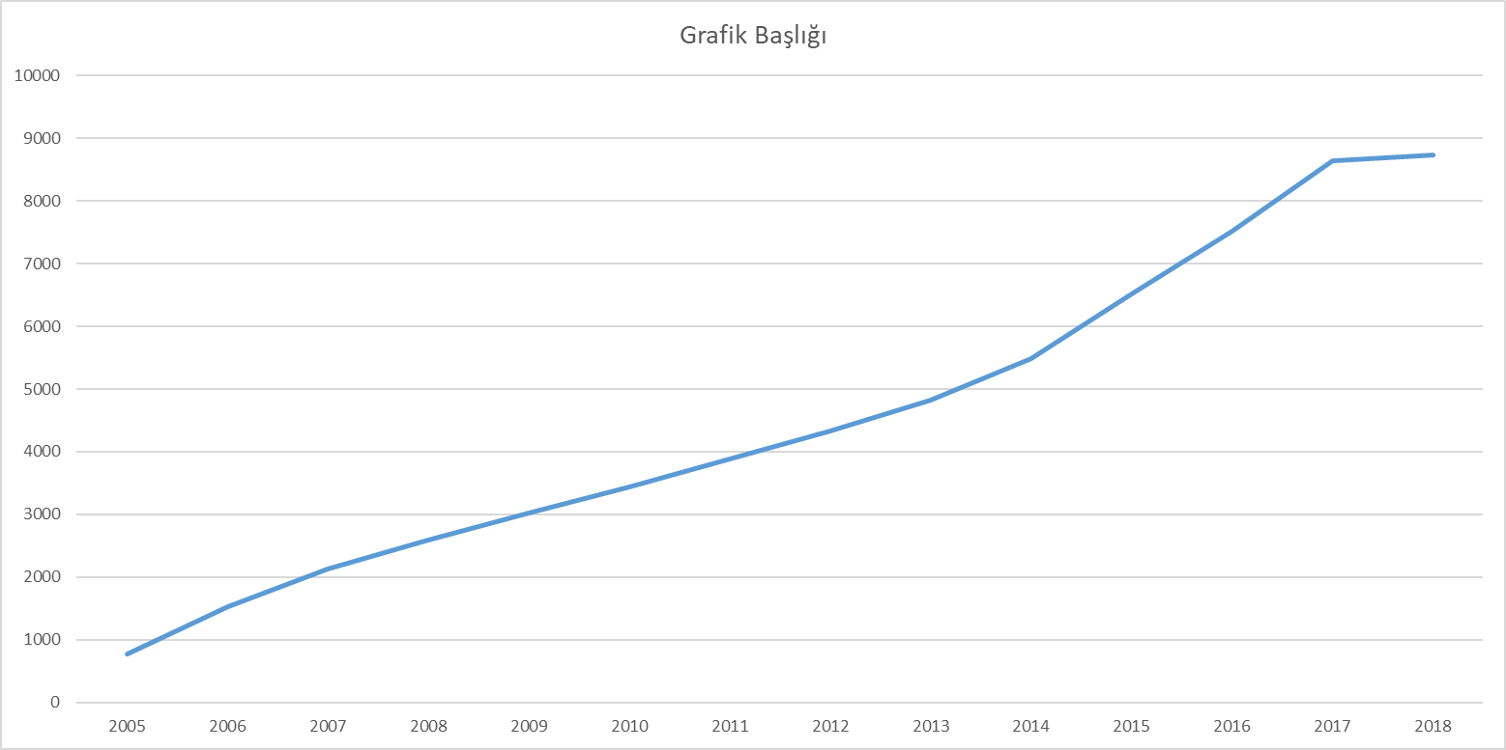

*A S-Curve is occured in this graph.* *There are our comments about case study information in*

*the part of conclusion.*

*6*

**Below are the patent numbers which are obtained by us for each site;**

WIPO🡪8729

USPTO🡪5916

TURKPATENT🡪17

**When we look at the contries;**

US is the country with the most patents.

US🡪4388

Finland🡪1812

South Korea🡪1174

Turkey🡪19

7

**Obtained IPC numbers;**

🡪G05D 🡪G07C 🡪G086

🡪G06Q 🡪G06T 🡪H04R

🡪H04N 🡪B60R 🡪H04M

This is Show that H and G are more than others IPC Numbers.

**KEY WORDS**

PHONE CAMERA

FRONT CAMERA

CAMERA

MEGAPİXEL

**8**

**Conclusion**

The tool that enables the images to be picked up, the receiver. The camera consists of

several basic elements: a reel (transmitter and receiver rollers) containing one blank, the

other recorded image; a mechanical mechanism that moves the teeth at different speeds in

front of the light window with the teeth entering and rotating in the filmin holes; an optical

system that allows light rays from the object to be collected to gather in the sensitive section

of the filmin.

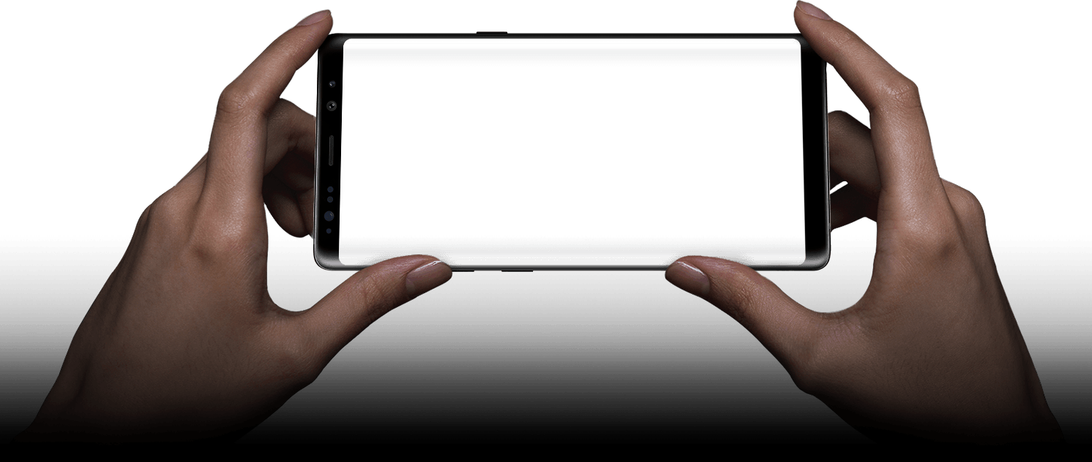

*When we look at the case study we did;*

*🡪 Almost every year, the number of patents related to the Phone Camera Sector has increased steadily. As a result, the total number of patents has increased and interest in this sector has been accelerated.*

*🡪When we look at the S-Curve in the last chart, we can see that the Phone Camera sector will be in a crucial place for companies and people in the future.*

***So, as a result of our case study, we can easily say that the***

***Phone Camera Sector is a very suitable sector for***

***investment and development***

*9*

***Prepared by;***

*Muhammed İsmail Yetkin-16069037*

*Mustafa Kaleli-16069002*

*İsa Özkara-15061605*

10